Irrigation Projects on the Pima Reservation: 1913-1922
Pima-Maricopa Irrigation Project Education Initiative
2002-2003

Restoring water to ensure the
continuity of the Akimel O’otham
and Pee Posh tradition of agriculture

Re

Part 27

At the same time as Community lands were being surveyed and prepared for allotment, the Indian Service (BIA) made plans to build an irrigation system for the Pima and Maricopa. This system was built to replace the traditional irrigation system in the Community that, because of upstream diversions of water, was no longer efficient. The new system was designed to provide water to the irrigable land allotments and was much larger than the system proposed by former Indian Irrigation engineer William Code, who sought to remove all the Pima and Maricopa to the Santan District. Code resigned from the Indian Service in 1911 and two years later the Indian Irrigation Service replaced the Reclamation Service as the agency responsible for building the irrigation system for the Community.
In March of 1913, the Indian Service assumed responsibility for the Sacaton Project, which was designed to irrigate 10,000 acres of land on the north side of the Gila River from Sacaton west to Stotonic. This system was begun by the Reclamation Service in April of 1908 as part of the scheme to relocate Community members to the Santan District. When it was replaced by the Indian Service, the Reclamation Service had installed eight of the ten wells for the project and had constructed twenty miles of canals, including turnout structures, and ten bridges.
While the Reclamation Service had built some canals and installed eight of the pumps, it had not built the distribution system needed to deliver water to Pima fields. In April of 1913, the Indian Irrigation Service began building laterals to carry water to each ten-acre irrigable allotment in Santan. Headgates and check structures were installed and wooden culverts and bridges were constructed. By 1915, nearly 60 miles of laterals had been built to irrigate 3,319 acres of land with well and floodwater from the Santan Floodwater Canal.
But while part of the distribution system was completed, there was still no diversion dam on the Gila River at the head of the Santan Floodwater Canal. Without this, it was nearly impossible for floodwater to enter the canal. While Pima farmers built brush dams in an attempt to push water into the canal, in 1913 and again in 1914, they could not divert enough water to maintain the velocity necessary to push the silt down the canal. As a result, the canal was “completely choke[d]” with silt by 1915, and was impossible to operate “until a diversion dam” could be built.
The distribution system was completed as far west as the present-day District 4 Service Center (where the eighth of ten wells was drilled), by 1915. But soon a variety of problems arose, including well casings filling with silt. The floods of 1914 damaged some of the laterals and the floodwater canal was left in a “very bad condition.” Irrigation Superintendent Charles Real Olberg did not recommend cleaning the canal unless a diversion dam could be built above its mouth on the Gila River. Due to the damage and the absence of a diversion dam, Olberg recommended water be diverted through the old Santan Canal, as it was the only canal capable of delivering floodwater to the irrigated lands in the Santan District. Until a diversion dam was built, water from the eight wells and what floodwater could be channeled through the old Santan Canal served just over 3,000 of the 10,000 acres projected as part of the Sacaton Project. By 1919, when it was completed, nearly $473,000 had been spent on the Sacaton Project.
In addition to the Sacaton Project, the Indian Service began a series of smaller irrigation projects between 1913 and 1916, designed to serve lands that were being allotted to Community members. In February of 1913, the Little Gila Project began for the purpose of restoring irrigation to land south of the main channel of the Gila River extending from Blackwater to Casa Blanca. The mouth of the Little Gila was opened and a timber head gate installed. Nearly 4,000 feet of the Little Gila River was excavated and cleared, with three wagon bridges built to facilitate transportation. When the Little Gila Project was completed, the main channel was opened and 1,000 acres of land was irrigated in District 1. Two wing dams diverted water into the Little Gila to distribute it to the land downstream.
The floods of 1914 also damaged the Little Gila River, with the winter flood destroying the headgate and washing large volumes of silt and drift into the channel. This driftwood piled up against the Blackwater flume, destroying it. The flume had been built over the Little Gila River to convey water through the Blackwater Island Canal, which served the land between the Gila and Little Gila Rivers. All three wagon bridges were damaged, along with 2,500’ of the Little Gila near Sacaton Flats. More than 6,000’ of new channel was dug to replace that damaged by the flood. When the work was completed, water was diverted into the Little Gila by using a brush dam. Despite these temporary dams, irrigation engineer Charles H. Southworth noted the flooding problems on the Little Gila demonstrated the need for “a permanent diversion dam.” The Little Gila Project was completed in 1917 at a cost of $21,197.
In November of 1913, the Indian Service began surveying lands north of Sacaton on what came to be known as the Agency Project. This project was designed to irrigate 2,000 acres north of the Pima Agency and located on another island between the Gila and Little Gila rivers. Water was provided to these lands by means of a canal that headed on the Little Gila River 1 ½ miles east of Sacaton. The canal carried 30 cubic feet per second (cfs) of water and branched into a series of smaller laterals. The land served by this project was once called the Old Santan District and the Cottonwood Canal District. By 1915, additional land had been cleared and put into cultivation. There were 800 acres of land irrigated by the end of the year, with several crops winning prizes at the Pima Agricultural Fair held in Sacaton. The project was completed in 1919 at a cost of nearly $43,000.
The Blackwater Project was initiated in 1914 and was at times referred to as the “B” Line Ditch. This canal headed one mile east of the reservation and was designed to serve 2,500 acres of land in the Blackwater District. This included the land in the Old Woman’s Mouth District, as well as the land in the Upper Blackwater Ditch. The canal was designed to convey 18 cfs of water. Flooding limited the full development of the Blackwater Project until after the construction of Ashurst-Hayden Diversion Dam, in 1921. Completed in 1918, the Blackwater Project cost $10,745.
In May 1914, the Casa Blanca Project was began and was to-date the largest irrigation project ever attempted in the Community. Designed to irrigate 35,000 acres of land, water was to be channeled through the Little Gila River to the lands west of Sacaton. This included land in Sweetwater, Bapchule, Alkali Village and Casa Blanca, as well as the lands of the Old Maricopa, Ancient Sweetwater, Mount Top and Sranuka districts. These latter districts were traditional farmlands that lost access to water with upstream diversions in the 1880s. In 1915, four miles of laterals were built along with several check structures. The canal headed on the Little Gila River and was designed to deliver 350 cfs of water into the newly constructed Casa Blanca Canal, which followed the Little Gila to the eastern boundary of District 5 before it continued west in a newly constructed canal. When the project was completed that portion of the Little Gila River west of Olberg Road became the Casa Blanca Canal.
In 1915, another lateral (lateral number 2) was constructed from the Casa Blanca Canal to deliver 130 cfs of water to 6,000 acres of land (potentially 11,000 acres if stored water could be secured) in the Sweetwater and Bapchule areas. Additional laterals were built to parallel the Casa Blanca Canal and deliver water to the lands near Casa Blanca. To prevent storm water damage to the canal (as occurred in 1914), the Indian Irrigation Service built “storm water inlets” out of concrete along the upper banks of the canal with a chute and apron on the opposite side to channel water away from the main canal. The Casa Blanca Project was completed in 1918 at a cost of $77,535.
With the 1914 flood damaging the south bank of the Gila River (and a half mile of the Sacaton Flats Canal) near Sacaton Flats, the Indian Irrigation Service began another project called the Sacaton Flats Project. This project repaired the damaged canal (sometimes called the Upper Stotonic Canal) and restored the embankments along the Gila River. This project was designed to serve about 900 acres of land east of Sacaton, although there were 1,105 acres farmed in the area as late as 1905. The Sacaton Flats Project was completed in 1915 at a cost of $790.
All of the irrigation works undertaken by the Indian Service prior to 1920 were on the eastern half of the Community and included land that would eventually lie within the San Carlos Irrigation Project. All of these projects combined, along with the electrical power lines to operate wells in the Santan District and the annual operating and maintenance expenses, totaled nearly $1,000,000. In 1922 the Lower Gila Project was begun to develop 1,500 acres of agricultural land in the Santa Cruz area. This project was completed that same year at a cost of $3,600.
Most of the irrigation projects were completed by 1916, when Agency Superintendent Ralph Ward boasted that irrigation conditions in the Community were better than at any other time in the past. Despite the new system, water resources on the reservation remained poor, inadequate and insufficient. The need for a diversion dam on the Gila River was a crucial piece missing from the developing irrigation system for the Community and there was still a need for a dam and reservoir to store water for the benefit of the Community. Despite these challenges, the Pima and Maricopa farmed nearly 10,000 acres of land by 1920, with an additional 2,500 acres leased to the United States Government as an agricultural experiment farm.

Irrigation Projects within the Community, 1913-1922

Using the reading selection, fill in the missing information related to the irrigation projects constructed between 1913-1922 within the Community. Some answers have already been provided. The missing information is listed below.

1,500 10,000 1919 Sacaton 1914
1,000 1913 1922 900 2,500
1914 1919 Sacaton Flats 35,000 1918
Blackwater/Casa Blanca 1918 1914 Santa Cruz

Project Started Completed Location Acres

Sacaton 1908 _________ Santan ______

Little Gila _______ 1917 ________ ______

Agency 1913 _________ ________ 2,000

Blackwater _______ _________ Blackwater ______

Casa Blanca _______ _________ Casa Blanca ______

Sacaton Flats _______ 1915 ________ ______

Lower Gila 1922 _________ ________ ______
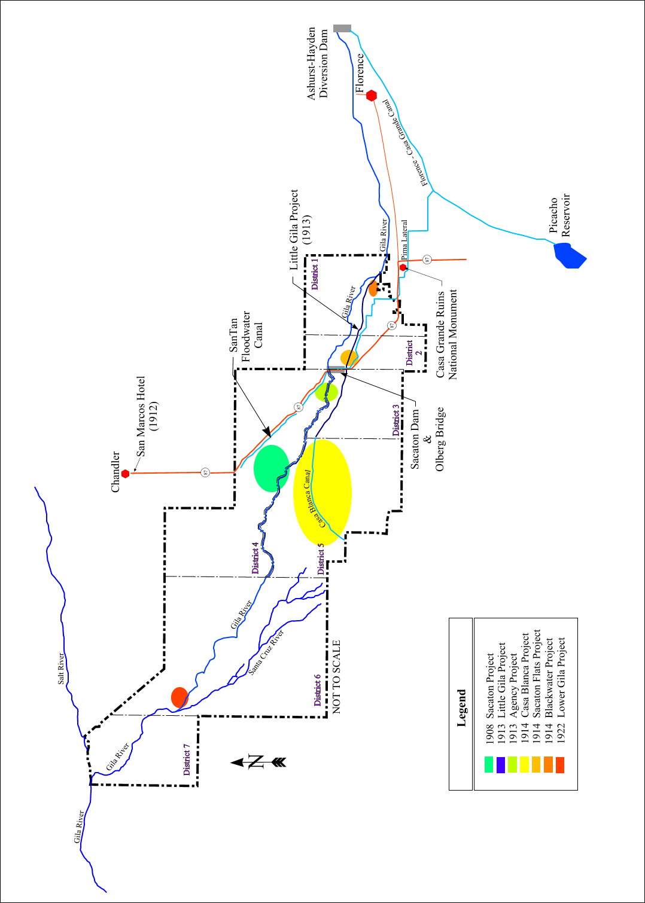
Teacher Plan for “Irrigation Projects on the Pima Reservation, 1913-1922”
Objectives

Students will be able to:

- List and identify the dates and places where the modern irrigation projects began within the Community.

- Map the general location of the irrigation projects that were constructed in the early 20th century.
Terms to know and understand

- Velocity
- Lateral
- Flume
- Driftwood
- Silt
- Brush dam
Critical Thinking:

- Many of the traditional farming areas within the Community were by-passed with the construction of the new irrigation projects. Areas around Snaketown, Sweetwater, and others no longer had the water needed to make the land productive. Some of the new lands developed in the area of Santa Cruz, Casa Blanca, Santan, Sacaton, Blackwater and others later went out of production due to insufficient water and/or poor soil. In the late 1920s, thousands of acres of land that had been prepared for agriculture were not farmed due to poor soil. Many landowners were even forced to exchange allotments because of poor quality soil. How might you have felt if you had lived during this time?

Activities:

- Remind students that William Code was the same man who ordered the closing of the Little Gila River in 1903. While Code claimed the Little Gila was closed to prevent flooding (and to protect the Pima villages and fields near the river) it appears from other accounts that his real intention was to deny water to the south side of the Gila River. This was done in an effort to persuade the Pima that they were without water and their only hope for survival was to move to the Santan District, where the Reclamation Service was building an irrigation system (Sacaton Project).
- Ask students if they know who or what Olberg Bridge was named after. Then introduce Charles Real Olberg. Olberg was an irrigation engineer for the Indian Service (BIA) and was responsible for building both Olberg Bridge and Coolidge Dam. He also oversaw the development of most of the irrigation projects within the Community prior to 1924.
- Have students take a blank map of the Gila River Indian Community. Then have students label the approximate location of the irrigation projects developed in the early twentieth century by the Indian Irrigation Service.
About P-MIP

The Pima-Maricopa Irrigation Project is authorized by the Gila River Indian Community to construct all irrigation systems for the Community. When fully completed, P-MIP will provide irrigation for up to 146,330 acres of farmland. P-MIP is dedicated to three long-range goals:
- Restoring water to the Akimel O’otham and Pee Posh.
- Putting Akimel O’otham and Pee Posh rights to the use of water to beneficial use.
- Demonstrating and exercising sound management to ensure continuity of the Community’s traditional economy of agriculture.

